ST MARY THE VIRGIN & ALLS
BULWELL PARISH MAGAZINE
THE HILL
SEPTEMBER 2021 Vol. 150 No 9

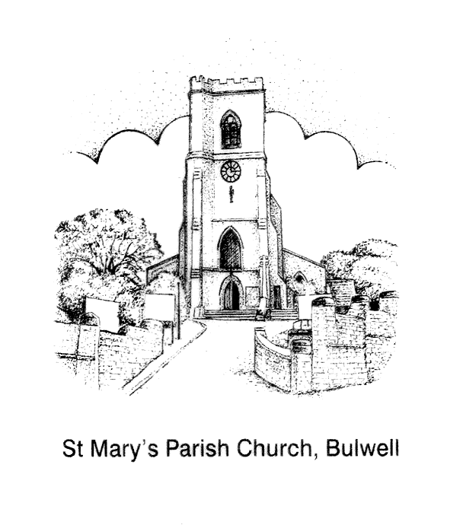

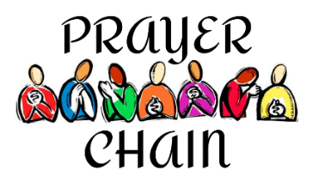
ST MARY’S PRAYER CHAIN
There are times when we all need that extra bit of support and love. Folk at St. Mary’s have been fortunate to experience the power of prayer, especially during the recent lockdowns, and have found comfort in the knowledge that friends are willing and happy to pray for us, or our loved ones.

Anne Elphick, one of our Licensed Lay Ministers (Readers), has set up a Prayer Chain ministry for St Mary’s Church. The Prayer Chain is a voluntary telephone or email set in motion whenever a request for prayer is received. The request for prayer will go out to a small number of people from St Mary’s who have been trained and authorised by Fr Andrew to receive Prayer Chain requests.

The Prayer Chain is another way for St Mary’s to be of service to others and to share our experience of God’s love, care and grace.

Requests for prayer via the Prayer Chain can be made by contacting Anne Elphick 07714 287 967 anne.elphick303@gmail.com or Roy Hadfield 07747 015 624 royhadfield@hotmail.com. If you wish to request prayer for somebody other than yourself, please make sure you have that person’s permission for them to be put onto the Prayer Chain. Emergency cases, especially involving members of the congregation should, of course, be referred to the clergy.
“Again, amen, I say to you, if two of you agree on earth about anything for which they are to pray, it shall be granted to them by my heavenly Father. For where two or three are gathered together in my name there am I in the midst of them” (Matt 18:19-20)

Every blessing, Fr Andrew
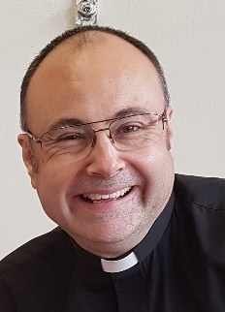
The Christian life can seem dry and hard going at times. The Bible can seem un-intelligible, going to church seems a struggle, and God can seem a million miles away.
YOUR VICAR WRITES
This reminds me of a young monk who once went to visit his Abbot to ask if he might give up his prayers because they seemed to be doing no good. “It’s the same when I read the Bible”, the monk added, “because I know it now by heart and I get no savour from it.”
The Abbot told the monk to pick up a dirty and broken basket which happened to be lying on the ground and asked him to fetch some water in it from a neighbouring stream. By the time the monk got back, there was not a drop in the basket.
The same obedience was asked of the monk every day for a week.
At the end of the week the young monk ventured to point out that the amount of water fetched from the stream would not fill a small cup.
“Never mind about that”, said the Abbot, “because it happens that I have as much water as I need. But if you look at the basket you will see that whereas it was dirty it is now clean.”
No one, of course, can find novelty in what may have become habitual. But this is no reason for us giving up reading our Bibles or going to church or saying our prayers. So long as we want to give glory to God in prayer and worship we can count on his grace which makes good our shortcomings. To give up on our faith is as silly as it is to give up sleep for the fear of sleeping badly or to give up eating for the fear of eating the wrong things.
This month, dear Reader, persevere in your faith. God is with you!
Every blessing Fr Andrew
Blessed is the one who perseveres under trial because, having stood the test, that person will receive the crown of life that the LORD has promised to those who love him.” James 1:12
SEPTEMBER REFLECTION WITH REV BOB
FLOWER – THE ASTER

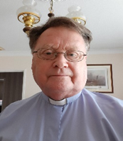
Autumn is approaching and looking at the Calendar cannot believe we are in September with evenings closing in and a slight chill in the air nature beginning it glorious Autumn colours before closing for the winter many animals will begin looking for a place to hibernate. But will it be the same with Climate Change we see changes in our weather patterns something we cannot ignore or believe , the Bible reminds us that Jesus said look at the birds of the air and animals of the field God tends and feeds them and we should not worry, very easy to say but in practice many are worried some have a form of fatigue brought on by the stress of the last eighteen months. What we can be sure is that God is with us in all things and as we watch the changes in nature, we also know that God is their being part of our worries, fears, and joys. As we approach the Autumn, lets embrace the colours of nature and see nature in
all its glory and thank God for the world we live in and that we have a responsibility to look after his creation.

In September, Fr Andrew and St Mary’s Parochial Church Council (PCC) are setting aside some time to think and pray about St Mary’s vision and mission going forward, and to try and encapsulate our thoughts in a Vision Statement and Mission Statement.
A VISION & MISSION STATEMENT FOR ST MARY’S
A Vision Statement is a one sentence phrase or slogan that presents a big picture, the hope and dream of what St Mary’s should be all about.
A Mission Statement is more of a concise plan, a set of goals or actions for St Mary’s and its programme of services and events.
Anne Elphick, one of our Licensed Lay Ministers, and the PCC Pastoral Care Subcommittee have already had some thoughts about possible Vision Statements:
- St Mary’s is a vibrant Church with living faith and real outreach into the community.
- St Mary’s is a living Church with vibrant faith and realistic outreach to the community.
- St Mary’s is a welcoming Church with strong faith and vibrant outreach to the community.
- St Mary’s is a growing Church that welcomes explorers in faith of every age and background.
And also, some thoughts about a possible Mission Statement:
- Isaiah 58: 6 – 8 - How could we reinterpret this for our Church in the coming five years?
- To grow in faith and worship so that we are deeply rooted in the love of God in all we say and do.
- Pray that we keep alert to the areas of priority where we need to go deeper in faith and be awakened to what the Holy Spirit can do amongst us as we work together.
- That we as a fellowship become aware of the deep needs that exist in our community of Bulwell. Together we will formulate a response and with God’s guidance plan how we can begin to reach out to the local community.
- Faithful to our Vision Statement we would meet, pray, worship and socialise together with hope and expectation that God would prosper the work we will engage in together.
- To discern the practical and spiritual gifts that God has given to our fellowship of faith so that the whole Church may become involved in the tasks we have identified.
- Each member contributing their prayers, experiences, time, resources and skills as they are able and willing; to honour the gift of love God has given us to share.
As part of this work, it would be great to hear from you! Please speak with Fr Andrew, Rev Bob, our Licensed Lay Ministers and PCC members and let us know the following:
- What do you want people to know about St Mary’s?
- What do people in the community say about St Mary’s (positive and negative)?
- What do you want people to learn or know about St Mary’s?
- What‘s the most important thing for you about St Mary’s?
Thanks in anticipation
Fr Andrew

THE HELPFUL LISTENER Part 1

BY FR ANDREW FISHER

Introduction: “He didn’t listen to me!”
In my mid-twenties I experienced an unshakeable call to ordination. God felt very close to me - as he still does - and coincidences happened in my life that all pointed towards God calling me to be a priest. On an almost daily basis people would talk to me about religious things, ask me if I was a priest, or enquire whether I had ever considered becoming a priest.
I was sent on a conference that explored the notion of calling, vocation and ordination. By nature I am not a very forthcoming person but, because of my experiences and the seemingly incessant strength of God’s calling, I plucked up the courage to speak with the priest who was leading the conference. I was told by him, almost immediately, that “these things don’t happen to people today!” and I was summarily dismissed. I still remember the frustration caused by the priest’s response; his lack of empathy, understanding and, most of all, the demeaning feeling of not being listened to.

The Swiss physician and author, Dr Paul Tournier (1898 – 1986) wrote:

In order to really understand, we need to listen, not reply. We need to listen long and attentively. In order to help anybody to open his heart we have to give him time, asking only a few questions, as carefully as possible in order to help him better explain his experience.

Paul Tournier (1967). “To Understand Each Other”, p.25, Westminster John Knox Press

When a person comes to experience the reality of the psychical and spiritual world they need to be listened to in order for them to better explain and explore their experience, and for them to integrate it into their everyday life. Helpful listening takes time and concentration. It often means putting aside what we might prefer to be doing, in order for us to pay proper attention to another person. Taking time to listen to another conveys certain attitudes to the person concerned. Through listening, we are saying to the other person that we have time for them; that they are worth us spending our time on them and that they, and what they have to say, is valued and taken seriously. Through listening, we accept those wanting to speak to us as another person. Refusing to listen is to reject both the person and their experiences and gives the impression that we have no time for them or what they are going through. Similarly, listening with divided attention implies that the person and their experiences are not worthy of our full consideration and attention. To listen with total, undivided attention indicates our respect not only for what is being said but also for the person who is speaking to us.

More next month ………………………..
FUTURE DATES

SATURDAY 2 OCTOBER 2021 Halloween – A most Christian Festival?
SATURDAY 9 OCTOBER 2021 Ghost, Ghouls and God
Both start at 6.30pm for 7pm – 9.30pm
Tickets £5 (available from the vicar) both talks featuring Matt Arnold Editor of The Christian Parapsychologist journal and researcher /writer for www.GhostsGhoulsAndGod.co.uk
FRIDAY 17 DECEMBER Christmas Band concert with the Nottingham based Band of The Royal Engineers – 7.30pm

Christian Aid are pleased to be supporting YCCN –

St Ives to Glasgow climate change pilgrimage - UPDATE
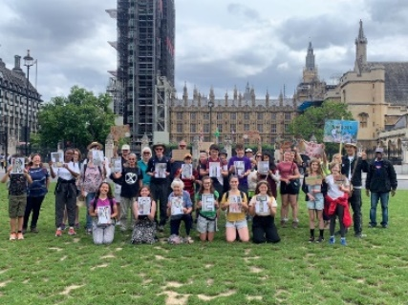

Thank you London!

We have had an absolutely amazing time in London , and the Relay has connected with so many people. Thank you to everyone who walked, hosted attended, cooked, prayed and supported in any way.

We took in Lambeth Palace, the Houses of Parliament, St Paul’s Cathedral, Westminster Cathedral, St James’s Park, and many more. We had a service at St Paul’s Clapham, morning prayer at Wesley’s Chapel and a Parish Eucharist at St Martin’s in the Fields. We had several Radio appearances, including Thought for the day. Some YCCNers spoke passionately about our cause at Lambeth Palace.

… AND THEY ARE COMING TO BULWELL SOON!

The pilgrimage (including the Rt Revd. Andy Emerton, Bishop of Sherwood) will be passing through:

Bulwell Bogs on Thursday Sept 2nd
between 1.45pm and 2.15pm.

St Mary’s will be hosting a meet and greet event for the walkers and providing refreshments.

It would be brilliant if people could join us and support the pilgrimage.

YCCN are still looking to find more walkers for the Bham – Notts section, if folk are interested in joining the walk please contact Gill Watts (Route Section Team Leader): g.a.watts@outlook.com

YCCN are an action-focused community of young Christians in the UK

aged 18-30, choosing to follow Jesus in the pursuit of climate justice
CHURCH CLEANING - PLEASE CAN YOU HELP?
A big ’Thank you’ to Sue & Dan, and Dougie & Sue for their hard work cleaning around the church building. Our church is big and to do it properly more help is needed. Is there anyone from the congregation who is willing help with this then Please contact Martin or Eleanor for more information and to express your willingness to help. Thank you.
ST MARY’S PARISH SHARE FOR JULY 2021

In July we were able to pay £ 2688.00 towards our Parish Share. This leaves a balance of £10315.00 to pay on or before January 2022, which means we need to raise around £2063.00 per month. Thank you everyone for your generous giving, supporting St Mary’s ongoing mission and ministry, especially in these most extraordinary of times.

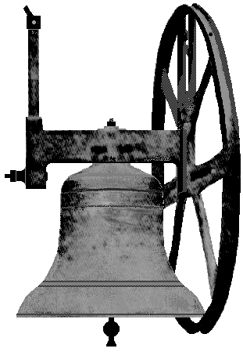
THE TOWER
How time flies! When the lockdown was relaxed, and six unrelated people were allowed to meet indoors it became possible for us to restart ringing for Sunday morning services. Since then, we have already rung for fourteen consecutive weeks. We have rung six bells weekly except for a self-isolation issue with two of our ringers reducing numbers to four and five only on two Sundays.
We are following strict safety procedures while ringing. This means that our risk assessment is still in force in respect of accessing the tower, ventilation of the ringing chamber, sanitization of ropes and hands and the wearing of masks. We now know that since the disease is air borne, masks and ventilation have increased in importance. A team of fully vaccinated pensioners could ring mask-less quite safely, but in our team we have one un-vaccinated student and two clinically vulnerable adults – so masks have to be worn.
The matter of ventilation seems to be gaining importance, some towers are quite small and stuffy, ours, at 16 feet square (4.8 metres square), with two opening windows and a door, seem to be quite reasonably ventilated. The windows are required to be open, and it has been noticed that outside windspeed and direction has some effect on the movement of air through the room. I wonder what this will be like in a few months when winter is upon us. Draughts have been quite noticeable in the past with the windows closed.
Things are however, looking good at the moment and when the holiday season is over we will be considering the reintroduction of a regular practice night. This will hopefully bring our ringers back to method ringing, which does seem to have been lost during the lockdown.
Robert Naylor – Tower Captain

A PRAYER TAKEN FROM THE C OF E WEBSITE.
God is with you, wherever you may be and whatever you may choose to do. When might you most need to keep this in mind?
Creator God,
you made us all in your image:
may we discern you in all that we see,
and serve you in all that we do;
through Jesus Christ our Lord.
Amen.

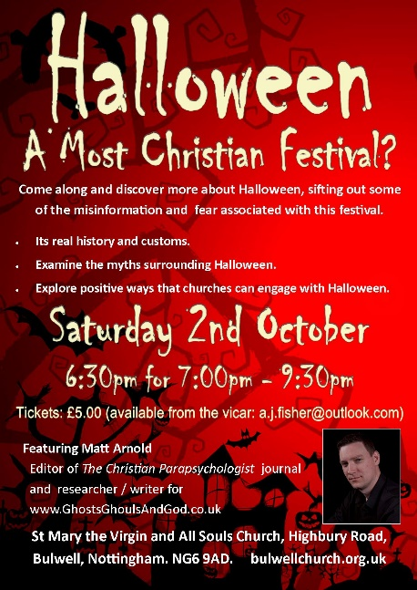

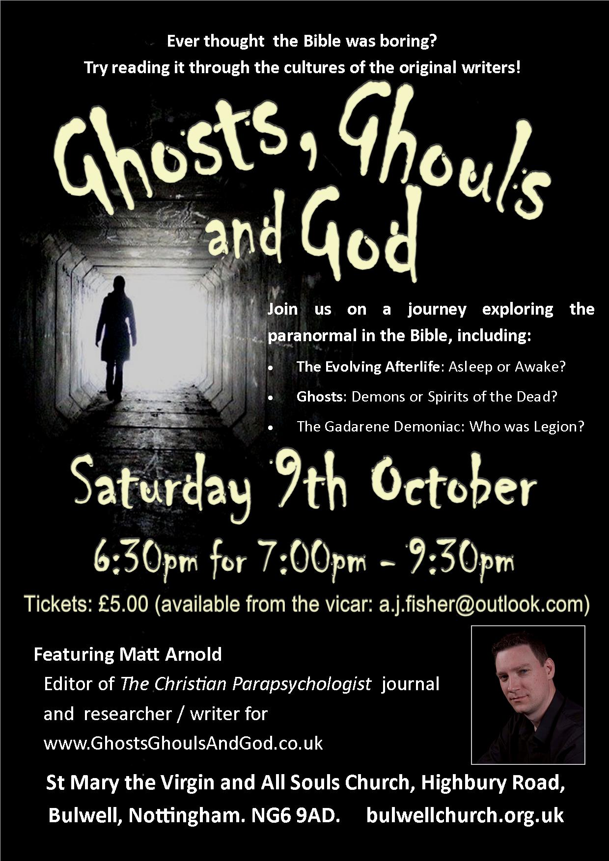

Marriage 7 August Zoe Sheehan and Colin Woodward
ST MARY’S PARISH REGISTERS
Please uphold in prayer, Zoe and Colin as they begin their married lives together,

Mr and Mrs Colin Woodward on their wedding day
Photograph taken by the altar, inside the church.

Photograph taken outside the church, by the South Porch door
‘Thank you Rev Bob for such a beautiful day on Saturday, it was amazing and so special. ‘
To book a wedding at St Mary’s please contact Fr Andrew Fisher
Baptisms 1 August Jeremiah Bartley
We remember the family and the Godparents of Jeremiah in our prayers and give thanks for their lives.
FOR YOUR INFORMATION

VIcar | Father Andrew Fisher | 0115 9755358  a.j. fisher@outlook .com
Honorary Associate Minister | Revd Bob Stephens | 0775422260 revbob63@sky.com
LLM’s (Licensed Lay Ministers) | Anne Elphick | 01159267007  anne.elphick303@gmail.com
 | Mary Jones | 0115 9751868  mj080249@gmail.com
Churchwardens | Eleanor Lang | 0115 9277212  ellielang@btinternet.com
 | Martin Walton | 07746 535552  Martinwalton57@outlook.com
Churchwarden Emeritus | Robert Naylor | 0115 9161787  jillian.naylor@ntlworld.com
Organist | Philip Miles | 07512 355185  pmiles2001@gmail.com
Tower Captain | Robert Naylor | 0115 9161787  jillian.naylor@ntlworld.com
Magazine & Notice Sheet Editor | Jillian Naylor | 0115 9161787  jillian.naylor@ntlworld.com

MAGAZINE INFORMATION A large print version of the magazine is available and can be obtained, to order only, from the Editor. Copy date for the October edition of The Hill is 15 September 2021

