ST MARY THE VIRGIN & ALLS
BULWELL PARISH MAGAZINE
THE HILL
NOVEMBER 2021 Vol. 150 No 11
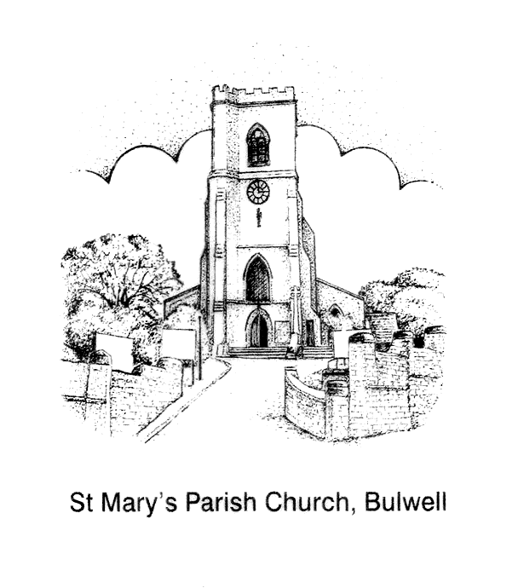

ST MARY’S IS A DOWN TO EARTH CHRISTIAN COMMUNITY SEEKING, SERVING AND WORSHIPPING GOD BY SHARING THE LOVE OF JESUS WITH ALL

YOUR VICAR WRITES
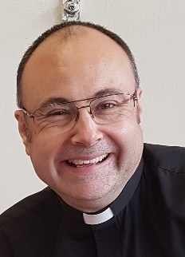
With superb handling qualities, stability in varying conditions and an amazing service record, the Supermarine Spitfire remains the most renowned British airplane of the Second World War. “The Spitfire always handled beautifully,” according to Group Captain Douglas Bader in the book ‘The Spitfire Story’. “It is a very satisfactory aeroplane to fly blind in cloud because of its inherent stability and it will stand a lot of punishment in the air.” Bader knew from experience the ability of the aircraft to resume its original flying position after being displaced.

Maintaining equilibrium and stability in all conditions are qualities we see in St Paul the Apostle, who wrote much of the New Testament. Despite the many buffetings he received from various groups of people he wrote,

“My friends, I want you to know what a hard time we had in Asia. Our sufferings were so horrible and so unbearable that death seemed certain. In fact, we felt sure that we were going to die. But this made us stop trusting in ourselves and start trusting God, who raises the dead to life.” (2 Cor 1:8-9)

The secret of St Paul’s composure and stability can be ours, too – it’s simply a matter of us asking for inner grace and power from the Lord.

God bless you this November

Fr Andrew
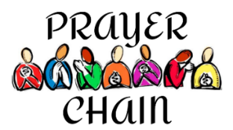
ST MARY’S PRAYER CHAIN
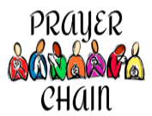
Requests for prayer via the Prayer Chain can be made by contacting Anne Elphick 07714 287 967 anne.elphick303@gmail.com or Lee Duffield - Simms 07706179327, leemduffield@gmail.com If you wish to request prayer for somebody other than yourself, please make sure you have that person’s permission for them to be put onto the Prayer Chain. Emergency cases, especially involving members of the congregation should, of course, be referred to the clergy.

CHRISTIAN MINDFULNESS MEETINGS HELD IN CHURCH
10am Refreshments - coffee & cake, followed by Christian Mindfulness meeting in the choir area of church. There will be a
light lunch at 12 noon, (please order beforehand from Joyce)
8 Nov.... Forgiveness
22 Nov... Trust
13 Dec... Love

HAVING FELLOWSHIP AGAIN TOGETHER
Over the past few months, due to covid restrictions, while we have met at church for services and had drinks afterwards, mostly outside, more informal fellowship has been limited. Recently several social events were held at church, a Hallowe'en talk, Ghosts, Ghouls and God talk and a Harvest lunch. Each event was well attended, and it was great to be able to have fellowship again, to invite new folk, and raise monies towards church funds also.

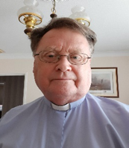
NOVEMBER REFLECTION WITH REV BOB
THE POPPY
November is a cold month, the start of winter, frosts and mists, cover the countryside. Also, a time of remembrance, as we think of the poppy and the sacrifices of men and women who have died or suffered in wars since the Great War of 1914-18. It is a hundred years since the Cenotaph was unveiled in Whitehall in London. I am Chaplain to the Local RBL branch and we will remember them, although for many it is not fashionable and does not fit into today’s society. Remembrance is how we learn lessons from the past. By sweeping it away, we fall into the same spiral before the two world wars. In that we also remember Jesus’ sacrifice for us on the cross. Jesus said, “Do this in remembrance of me, so that you might have life eternal”, as we also remember the sacrifice of those who died and suffered for our freedom. On the 11th month at the 11th hour "They shall grow not old, as we that are left grow old,
Age shall not weary them, nor the years condemn.
At the going down of the sun, and in the morning,
We will remember them Kohima Epitaph
'When You Go Home, Tell Them of Us and Say,
For Your Tomorrows, We Gave Our Today.'

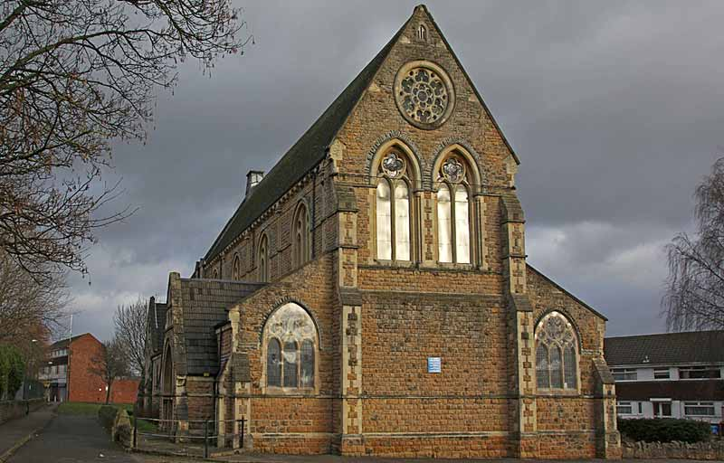
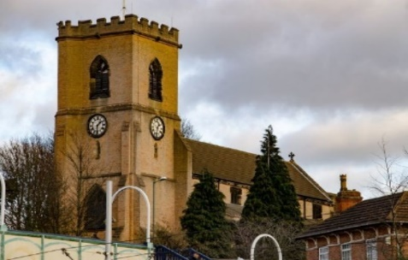

TWO CHURCHES’ CHRISTMAS GET TOGETHER
St Mary’s & St John’s folk are invited to come together and share festive fun, fellowship, food and drink.

3-5pm Saturday 4th December
St Mary’s Upper Hall
EVERYBODY WELCOME!

++++++++++++++++++++++++++++++++++++++++++++++++++++++++At the end of October the Chaplaincy Team and Fr Andrew led a service and blessed a Memorial Stone at Highbury Hospital remembering staff and patients whose lives have been touched by covid. Kind thanks again to Nigel Lymn-Rose and the team at Lymn’s Funeral Directors for their support of the communities in Bulwell, and their generous gift of the Memorial Stone.

Staff made a recording of the service for folk who could not be present. The service can be watched online at:

https://www.youtube.com/watch?v=QlzZfRTvz-M
Living In Love & Faith’ is a Church of England initiative to encourage engagement across the whole Church with Christian teaching about identity, sexuality, relationships and marriage.
The Diocese of Southwell & Nottingham is committed to participating in ‘Living In Love & Faith’, and Fr Andrew and members of St Mary’s Pastoral Care Committee will be running an informal five session course on ‘Living in Love and Faith’ in November. All are welcome.
The course will be held on the following Monday evenings in November, 6pm in the West Room:
Monday 8 November ‘Learning Together’ (Facilitator - Fr Andrew)
What does it mean to learn together as followers of Christ?
Monday 15 November ‘Identity’ (Facilitator - Mary Jones)
How does our identity in Christ relate to sex and gender?
Monday 22 November ‘Relationships’ (Facilitator - Anne Elphick)
What kind of relationships does God call us to?
Monday 29 November ‘Sex’ (Facilitator - Fr Andrew)
Where do our bodies and sex fit into all of this?
Monday 6 December ‘Life Together’ (Facilitator - Rev Bob).
How do diversity and difference affect our life together as a church?
The breadth of teaching and doctrine in this whole area is wide and varied, so good listening, mutual respect, and patience will be encouraged. Sharing one another’s life experience is important so that we can learn from each other. Folk who may have been wounded in the past will be able to share their experiences, as much as they feel able, in a calm, support and non-judgmental environment.
‘Living in Love and Faith’ is not about changing people’s minds or rubbishing deeply held beliefs; rather it is about hearing from each other, to seek to understand the pain of the past, and to find a way forward as a church that honours God and all of God’s children.
If you would like to come on the course, please let me know or sign up on the list at the back of church.
God bless Fr Andrew
ON COVID AND LOCAL CHURCHES

“The way the churches switched to operating online was a triumph, a piece of divine redemption. The great gain for individuals is that they can access any church in the world at any time of their choosing, wherever they are, on whatever device they have.
“Former churchgoers now too frail for the pews can remain in the congregation. Those who are away, ill, working or otherwise busy, can still attend church, a bit later on. Spiritual seekers, who formerly would not have known where to start, can now begin their journey to Jesus online.”
The Ven Bob Jackson, author, church growth consultant, and Visiting Fellow St Johns College Durham, talking to Church Times.

THE TOWER
Did you hear the bells ringing last Saturday evening?
Sometime in September we were alerted by the Central Council of Church bellringers (CCCBR) to the possibility of ringing to mark the opening on Sunday 31 October 2021 of the Climate Change Conference of Nations, in Glasgow. The request came on the 19 October and The Lord Bishop of Norwich, the Rt Revd Graham Usher, Lead Bishop for the Environment said, “I am happy to endorse a nationwide ‘ring out for climate’ on the eve of the COP26 as a symbol of warning, but also of hope.”
This is not a new idea. Bells rang worldwide against climate change before the Copenhagen conference in 2009. Maybe we need to ring louder. The call was to ring on Saturday 30 October at 6pm, worldwide.
After arranging to ring, with our own clergy, we managed to assemble a team of six ringers and rang ’60 on thirds’. This is a Devon Call Change composition and one which we are learning at present.
COP26, stands for the 26th Conference of Participants. 25 Conferences have already taken place worldwide, and whilst some progress has been made, it is not enough, and the situation is becoming urgent. We all need to pray for the success of the conference, for the co-operation of the participants, and that proposals and decisions made will be turned into effective action. It is not too late but in some parts of the world the situation is becoming desperate, and all nations need to act together. Robert Naylor- Tower Captain
The first few of 19,000 churchyards have been surveyed as part of a Church of England project to create a free digital map of every grave and feature in every churchyard in the country.
NATIONWIDE DIGITAL CHURCHYARD MAPPING PROJECT UNDERWAY

The ancient church of St Bega on the shores of Lake Bassenthwaite in the Diocese of Carlisle was the first churchyard to be scanned by the surveyors, using sophisticated laser equipment, as part of the national programme.

A new website will go online in the new year, giving free access to the map. It is expected to be of special interest to local community groups, conservationists, and those researching family history. The website will also enable the charting of biodiversity and green technology.

The Church of England has partnered with Cumbrian-based surveying company Atlantic Geomatics who will use back-pack mounted laser scanners to map churchyards. They will also photograph all the visible headstones.

There are around 19,000 Anglican burial grounds in England, and the ambitious scheme will aim to digitally survey the majority over the coming seven years. Data on burials will be combined with other information, such as the National Biodiversity Network Atlas, to present the most complete picture of churchyards to date.

The project will come at no cost to parishes or dioceses in the Church of England and parishes will have free access to the map through a new web-based record system which is set to launch in Spring 2022. There will also be the option to subscribe to additional services.

Substantial funding for the programme has been given by Historic England, with the National Lottery Heritage Fund and Caring for God's Acre supporting the pilot phase, as well as support from genealogy research websites.
As well as details of burials, the online interactive map will detail biodiversity in churchyards, including ancient trees and plant-life, as well as green technology such as solar panels.
SMILE LINES

HOLD HER HAND While out in the town, I saw an elderly couple holding hands while they were walking. As they approached, I commented on how romantic it was.
The man replied, “We have been holding hands when we go out in public for over 30 years. I have to. If I let go, she shops.”
++++++++++++++++++++++++++++++++++++++++++++++++++
THE CONGREGATION A minister was considering a move to a busy town-centre church, and wanted to know what the congregation were like, and especially the church council. So, he rang the minister who had just retired from that church.
The retiring minister hesitated a moment and then replied: “Some of them are wise; some are otherwise
The Helpful Listener

THE HELPFUL LISTENER Part 3

BY FR ANDREW FISHER

A helpful listener’s warmth and attention seeks to express the two basic characteristics of Christian relationships; ‘love thy neighbour’, and ‘judge not’. Warmth is that genuine care for another person which expresses itself in concern for another's well-being. It implies that we feel positive towards the speaker, rather than neutral or negative, and that we have respect for the speaker’s worth as an individual and their right of self-direction. Our love and support are there if it is wanted but cannot be imposed. Warmth must be authentic if it is to be communicated effectively.

To be both warm and non-judgmental means that the helpful listener accepts the other person as they are and is warm towards them without conditions. The helpful listener cares for the other as a separate person, with their own ideas, experiences, beliefs and feelings. To be able to express such unconditional regard, particularly to somebody whose background, beliefs and experiences are totally different from theirs, the helpful listener needs to be open and appreciative of different thought and value-systems. The helpful listener also needs to be open to their own feelings, thoughts, and experiences, and to be able to face and to accept all that is within themselves - guilt, bitterness, resentment, hostility etc, as well as the more acceptable and pleasing characteristics. As Jesus demonstrates in John 8:1-11, only when the listener can truly begin to accept themselves, with all their faults and foibles, can the listener really begin to accept another. The listener who demonstrates a capacity for openness and freedom to be their true self can become a helpful model for the speaker and creates a secure and safe environment in which the speaker can begin to express and explore themselves and their experiences.
DATES FOR YOUR DIARY
Thursday 11 NOVEMBER 11am ACT OF REMEMBRANCE outside church at the War Memorial – meet at 10.50am

Sunday 14 NOVEMBER NB 9.30am Parish Mass
11am ACT OF REMEMBRANCE at the War Memorial outside – meet at 10.50am - NO PROCESSION - NO SERVICE IN CHURCH
SATURDAY 27 NOVEMBER 11am – 2pm CHRISTMAS FAYRE.
Saturday December 4 TWO CHURCHES CHRISTMAS GET TOGETHER (see advert on page 5)
FRIDAY 17 DECEMBER CHRISTMAS BAND CONCERT With ever increasing covid numbers and in agreement with the Band , the concert for this year has had to be cancelled. Restrictions apply to the spacing of the band, so accommodating them and an audience would be difficult.
CHRISTMAS FAYRE – more details Help is needed on the day for setting up and on the day for clearing up. Items needed for the Fayre include tombola and raffle prizes (separate hamper items including chocolate and food items) new and nearly new items bottles, book, toys including clean, soft toys and any other items which you think would sell. Please NO bric a brac.
MAGAZINE INFORMATION A large print version of the magazine is available and can be obtained, to order only, from the Editor. Copy date for the December edition of The Hill is 15 November 2021

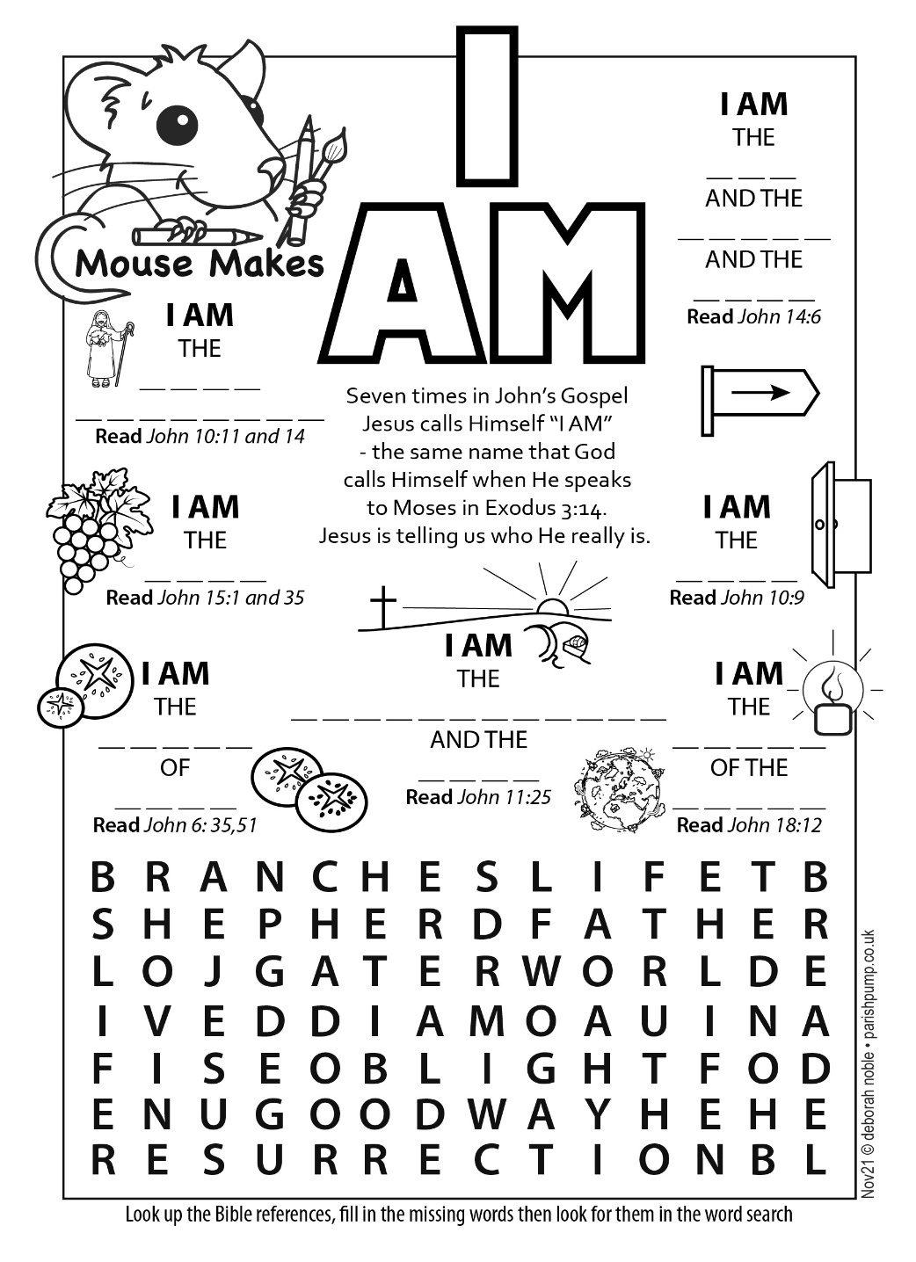
WEDDING
ST MARY’S PARISH REGISTERS
16 October Leonard Butler & Hayley Bensley
Please uphold in prayer, Leonard & Hayley as they begin their married life together
BAPTISMS
17th October Chidiebere Favour Kalu - Mother
17th October Chidere David Anyanwu - Son
We remember their family in our prayers.
INTERMENT OF ASHES
30 September Stephen Glover
17 October Eric and Elsie Dibsdale
24 October Derek and Dorothy Holey
FUNERALS
30 September Dorothy Holey
22 October Julie Gee - Gedling Crematorium
We give thanks for the lives of these loved ones and remember their families in their grief, that they may know the peace of God.
FOR YOUR INFORMATION
Vicar | Father Andrew Fisher | 0115 9755358  a.j. fisher@outlook .com
Honorary Associate Minister | Revd Bob Stephens | 0775422260 revbob63@sky.com
LLM’s (Licensed Lay Ministers) | Anne Elphick | 01159267007  anne.elphick303@gmail.com
 | Mary Jones | 0115 9751868  mj080249@gmail.com
Churchwardens | Eleanor Lang | 0115 9277212  ellielang@btinternet.com
 | Martin Walton | 07746 535552  Martinwalton57@outlook.com
Churchwarden Emeritus | Robert Naylor | 0115 9161787  jillian.naylor@ntlworld.com
Organist | Philip Miles | 07512 355185  pmiles2001@gmail.com
Tower Captain | Robert Naylor | 0115 9161787  jillian.naylor@ntlworld.com
Magazine & Notice Sheet Editor | Jillian Naylor | 0115 9161787  jillian.naylor@ntlworld.com

